**F. Y. B. Tech Academic Year 2020-21**

**Trimester:I Subject:** Basics of Electrical and Electronics Engineering

**Name ------------------------------ Division ---------**

**Roll No ---------------------------- Batch ----------**

**Experiment No:7**

**Name of the Experiment:** Verification of Kirchhoff’s current law (KCL) and Kirchhoff’s voltage law (KVL)

**Performed on: -----------------------------------------------**

**Submitted on: -----------------------------------------------**



**Aim: Verification of Kirchhoff’s current law (KCL) and Kirchhoff’s voltage law (KVL)**

**Objectives**

* To get the idea of analysing the circuits
* To solve the electrical circuit theoretically
* To verify practical and theoretical value

**Components and equipment required**

| **Components** | **Specification** |
| --- | --- |
| DC Ammeters | 0 – 1 A (3 No.) |
| DC Voltmeter | 0 - 20 V (1 No.) |
| Circuit board | Same as shown in Fig.3 |
| DC Power supply | 0 – 15 V (2 No.) |

**Theory**

A German physicist Gustav Kirchhoff developed two laws enabling easy analysis of an interconnection of any number of circuit elements. The first law deals with the flow of current and is popularly known as **Kirchhoff’s Current Law (**KCL) while the second one deals with the voltage drop in a closed network and is known as**Kirchhoff’s Voltage Law** (KVL).

1. **Kirchhoff’s current law**

It states that, at any moment, the algebraic sum of currents flowing through a point (or junction) in a network is Zero or in any electrical network, the algebraic sum of the currents meeting at a point (or junction) is Zero. This law is also known as Point Law. In other words, the sum of the currents flowing towards a point is equal to the sum of those flowing away from it.

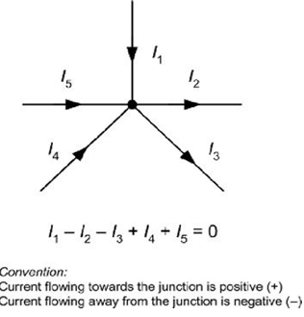

**Fig. 1: Kirchoff’s current law**

In Fig.1, currents I1, I4 and I5 are flowing towards the node, are considered as positive. At the same time, currents I2 and I3 are leaving the junction, are considered as negative. As per KCL, sum of all the currents is zero. That means sum of currents entering the node and sum of currents leaving the node is equal.

1. **Kirchhoff’s voltage law**

It states that, in any closed loop (mesh), the algebraic sum of the EMFs applied is equal to the algebraic sum of the voltage drops in the elements. It is also known as Mesh law.

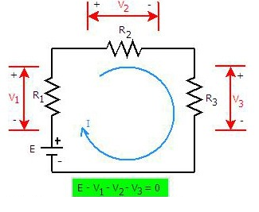

**Fig. 2: Kirchoff’s voltage law**

**Component Values used:**

**Voltage source E=**

**R1= , R2= R3=**

**Circuit diagram**

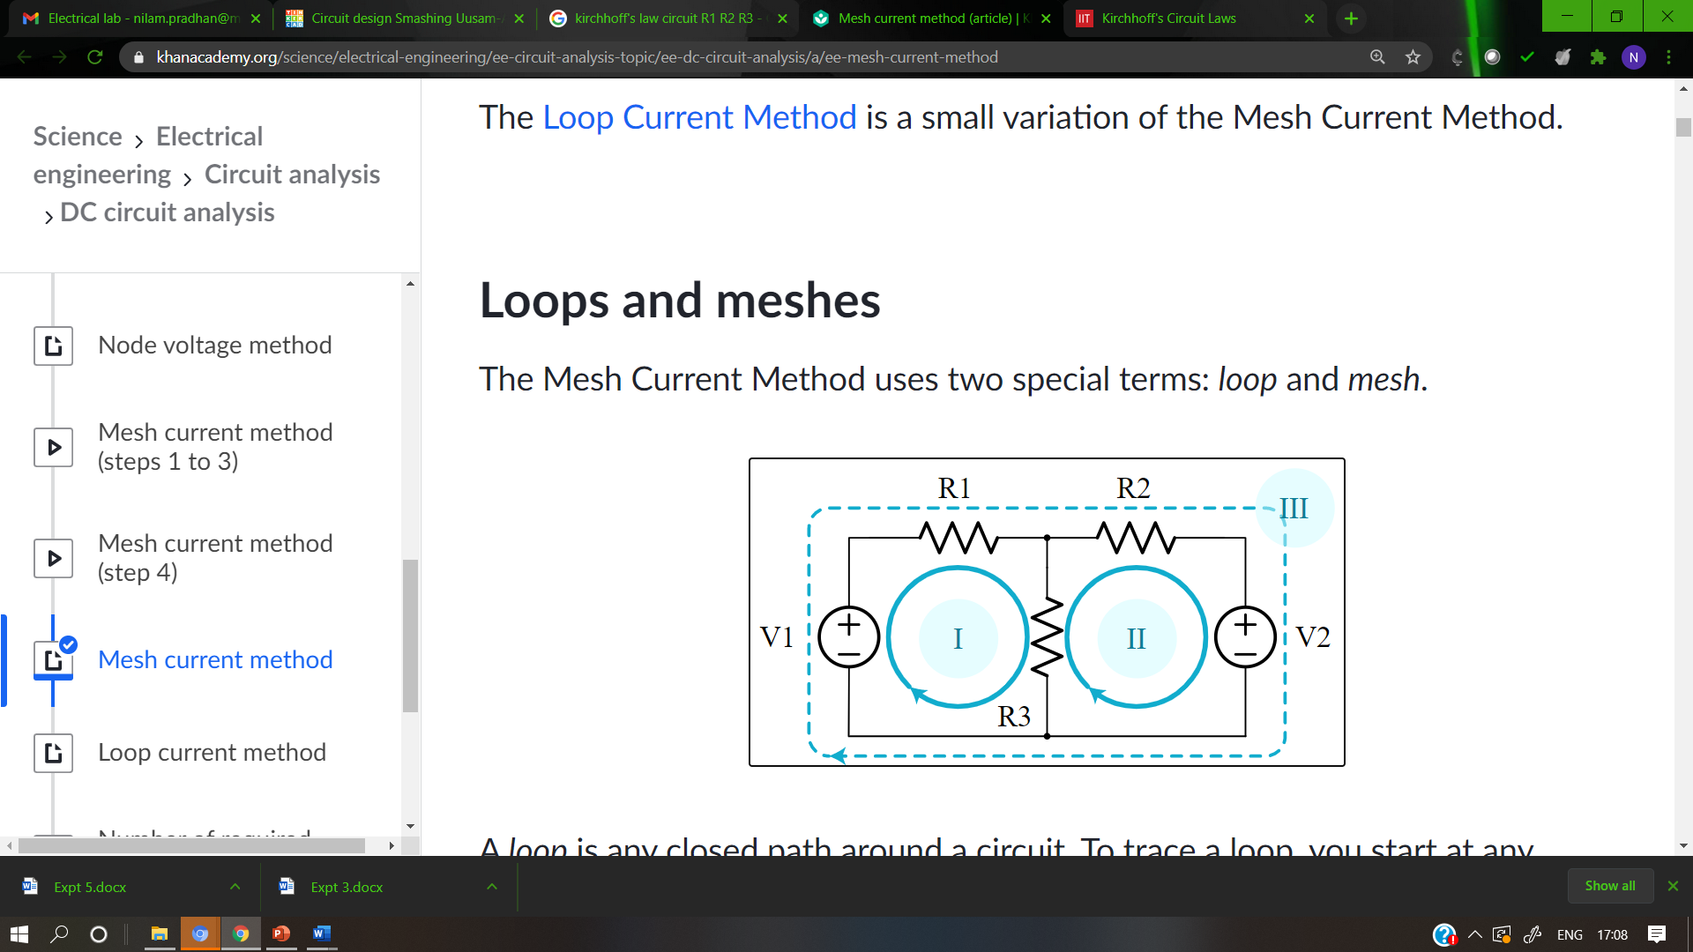Mesh current method (article) | Khan AcademyMesh current method (article) | Khan Academy

**Components used in the circuit**

**V1 = _____V**

**V2 = _____V**

**R1 = ________Ω**

**R2 = _____Ω**

**R3 = _____Ω**

**Procedure:**

**A. KCL**

1) Connect the circuit as shown in the diagram

2) Measure currents in every branch and note it in observation table as practical value.

3) Calculate theoretical current values using mesh equations

1. **KVL**

1) Connect the circuit as shown in the diagram

2) Using a voltmeter, measure the source voltage Eand the voltage drop across the resistances R1, R2 and R3.

3) Find the current I= E / R1+R2+R3

4) Calculate theoretical values as V1=IR1, V2=IR2, V3=IR3

**Observation Tables:**

1. Verification of KCL-

| **Current (A)** | **Theoretical Value** | **Practical value** |
| --- | --- | --- |
|  |  |  |
|  |  |  |
|  |  |  |

Calculate and compare it with. These two values should be equal.

1. Verification of KVL-

| **Voltage (V)** | **Theoretical Value** | **Practical value** |
| --- | --- | --- |
|  |  |  |
|  |  |  |
|  |  |  |

,and are the voltage drops across resistances R1 R2 and R3. Calculate and compare it with E. These two values should be equal.

**Conclusion**

**________________________________________________________**

**________________________________________________________**

**Post-Lab Questions**

1. Theoretically calculate the voltages and currents for each element in the circuit and compare them to the measured values.
2. Calculate the percentage error in the two measurements and provide a brief explanation for the error.

**Note: Students are instructed to do all necessary calculations and answer the questions on separate sheets and attach them.**

